PayBookClub
The Aandaal Project | PAYBO Token Platform
Investor Summary | May 2026
70,000+  Registered users | 19,516  Active users | 11,289  Cashout events | 5.6 years  Live on market

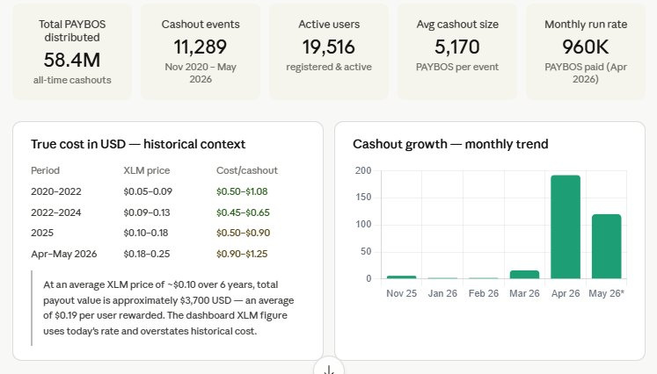
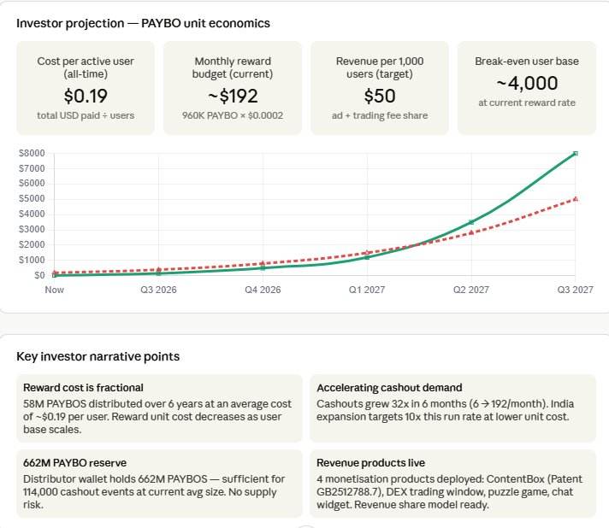

1. Executive summary
PayBookClub is a social rewards platform with 70,000 registered users across Africa and India. Users earn PAYBOS — utility tokens on the Stellar blockchain — through in-app activity including content creation, trading, gaming, and community engagement. PAYBOS are exchangeable for XLM via the Stellar DEX, then converted to local fiat via partner exchanges.
The platform has been live since 2020, has processed 11,289 cashout events, and is now expanding into India via a CoinDCX partnership outreach. Four revenue products are live with a patent-registered ContentBox (UK Patent Application GB2512788.7) and a growing DeFi trading window.

2. Legal structure
Issuing company | Capexsales Ltd, UK
Company number | 7161555
ANDAL entity | Aandaal.io Community Interest Company (CIC)
PAYBO token | Stellar blockchain, issued by Capexsales Ltd
PAYBO issuer wallet | GDNUDY5LNUVCO55LLK6H2RCOILB6EO7UOVAOGDTV3FB7Y2U45TMAXD3D
Circulating supply | 998,297,413 PAYBOS
Distributor reserve | 662,000,000+ PAYBOS (Stellar wallet GA7ASK...)
StellarExpert rating | 6.3 / 10

3. Traction & user metrics
58.4M  PAYBOS distributed | 471,651  DEX trades all-time | 2,130  Trustlines | $2,290  Liquidity pool value

Cashout demand has grown 32x in 6 months, from 6 monthly events in November 2025 to 192 in April 2026, reflecting increasing user trust and token utility.

Period | Monthly cashouts
Nov 2025 | 6
Jan 2026 | 2
Feb 2026 | 2
Mar 2026 | 16
Apr 2026 | 192 (+1,100% vs Nov)
May 2026 (partial) | 120+

4. Unit economics & cost of rewards
The dashboard reports cashout costs in XLM using the live PAYBO/XLM rate. This overstates historical cost because XLM was trading below $0.09 for most of the platform's history, having only recently risen to $0.25. The true dollar cost of all rewards distributed since 2020 is approximately $3,700 USD at a weighted average XLM price of ~$0.10.

Period | Avg XLM price
2020–2022 (launch) | $0.05 – $0.09
2022–2024 (growth) | $0.09 – $0.13
2025 | $0.10 – $0.18
Apr–May 2026 | $0.18 – $0.25
Weighted average (6 yr) | ~$0.10 per XLM

$3,700  Est. total rewards paid (USD) | $0.19  Cost per active user | $0.33  Cost per cashout event | 662M  PAYBO reserve remaining

At the current reward rate of ~5,000 PAYBOS per cashout and a reserve of 662 million PAYBOS, the distributor wallet supports approximately 132,000 further cashout events — sufficient for several years of growth at projected rates without token replenishment.

5. Revenue products (4 live)
Product | Status & revenue model
ContentBox | Live — UK Patent GB2512788.7. Embeddable content widget with PAYBO reward triggers. Revenue: ad impression share + PAYBO activity.
Trading Window | Live — Stellar DEX BUY/SELL/SEND interface in app. Revenue: trading fee share + spread. Daily leaderboard with 15,000 PAYBO prize pool.
Tamil Heritage Puzzle | Live — Multiplayer in-browser game, no download required. Revenue: PAYBO activity share on completions. Free embed for partners.
Community Chat Widget | Live — Embeddable chat backed by 70,000 verified users. Revenue: ANDAL Coin activity + premium channel fees.

6. India expansion strategy
- CoinDCX outreach initiated May 2026 for XLM-INR offramp partnership
- ANDAL token (cultural heritage RWA) positioned as India entry vehicle via Tamil diaspora community
- 19,516 active users provide proven base for referral-led India growth
- Target: 50,000 India users within 12 months via community-first marketing
- India-specific features identified via in-app feedback quiz: cricket/Bollywood content, UPI integration, INR cashout

7. Financial projection (2026–2027)
Metric | Now (May 2026) → Target (Q3 2027)
Monthly active users | 19,516 → 100,000+
Monthly cashout events | 120–192 → 2,000+
Monthly reward cost (USD) | ~$192 → ~$2,000
Monthly revenue (est.) | ~$20 → ~$8,000
Break-even user count | Target ~4,000 paying/active users
Revenue at 100K users | $5,000–$10,000/month (conservative)

Revenue assumptions: $0.05/user/month average from ContentBox ad share, $0.02 per DEX trade, $0.10/month per premium chat channel. Projections are conservative and do not include ANDAL token sale proceeds or India-specific monetisation.

8. Technology stack
- Stellar blockchain — PAYBO and ANDAL tokens, DEX trading, atomic payments
- AWS EC2 Ubuntu server — Node.js/Express API, PM2 process management
- MongoDB — user profiles, cashout history, content, quiz responses
- Cloudflare — CDN, DDoS protection on paybook.club and andal.io
- React Native mobile app — version 135 (5.3.3), 10,850 installs
- Developer portal — api.paybook.club with live API endpoints and tokenomics docs

11. Investment opportunity
PayBookClub is seeking strategic partners and investors to accelerate India market expansion and product development. Use of funds:
- India market launch — localisation, UPI integration, CoinDCX partnership execution
- App development — video content layer, dating/matchmaking feature, India-specific game content
- Security audit — CertiK/Hacken PAYBO token audit (Q3 2026)
- ANDAL token launch — tokenomics document, CIC governance, community sale
- Marketing — referral campaigns, influencer partnerships in Tamil diaspora communities

10. The investor narrative — why now
The unit economics story
PayBookClub has paid out real value to 19,500 users over 6 years at an average cost of just $0.19 per user. This is lower than virtually any user acquisition cost benchmark in social media — industry averages for comparable apps range from $3 to $5 per active user acquired.
The total dollar cost of all 58.4 million PAYBOS distributed since 2020 is approximately $3,700 USD, calculated using a weighted average XLM price of ~$0.10 over the platform's history. The dashboard reports costs in XLM using the current live rate, which overstates the historical figure — XLM traded below $0.09 for the majority of the platform's life before rising to $0.25 in 2026.

Accelerating organic demand
Cashout demand has grown 32x in just 6 months: from 6 monthly events in November 2025 to 192 in April 2026. This is not marketing-driven — it reflects genuine user trust and growing token utility as the PAYBO/XLM rate has improved and awareness of the cashout mechanism has spread organically through the community.
The monthly cashout trajectory (6 → 2 → 2 → 16 → 192 → 120+) shows a classic inflection pattern. The April 2026 spike of 192 events in a single month represents a step-change in user behaviour, coinciding with the launch of the in-app trading window and the PAYBO price improvement to 1,500+ PAYBOS per XLM.

Reserve capacity — no supply risk
The distributor wallet (GA7ASKBRHIEXS7WHHKY67J5XMONFY6DARWQEV46IH3BPVW3HXRMVFIOP) holds 662 million PAYBOS. At the current average cashout size of 5,170 PAYBOS per event, this reserve supports approximately 128,000 further cashout events — equivalent to more than 5 years of growth at the April 2026 run rate, or over 600 months at the historical average. There is no token supply risk for the foreseeable future.

Path to profitability — conservative projection
Revenue is expected to cross reward costs around Q1 2027, driven by three factors: India market expansion via the CoinDCX partnership adding 50,000+ users; activation of ContentBox ad revenue sharing (Patent GB2512788.7 accepted); and growing DEX trading fee income as daily trading competition drives volume.
The projection below is deliberately conservative — it uses $0.05/user/month from ContentBox, $0.02 per DEX trade, and $0.10/month per premium chat channel. It does not include ANDAL token sale proceeds, India-specific partnerships, or B2B white-label revenue from the embeddable products.

Metric | Now (May 2026) | Target (Q3 2027)
Monthly active users | 19,516 | 100,000+
Monthly cashout events | 120–192 | 2,000+
Monthly reward cost (USD) | ~$192 | ~$2,000
Monthly revenue (est.) | ~$20 | ~$8,000
ContentBox revenue | Pre-launch | $500+/mo
DEX trading fee share | Early stage | $1,000+/mo
Chat widget premium | Pre-launch | $500+/mo

Why the timing is right
- XLM price improvement (from $0.05 to $0.25) has made cashouts meaningfully valuable to users for the first time, driving the 32x growth surge
- India crypto market maturation — CoinDCX serves 15 million+ users with INR offramp, making PAYBO cashout directly actionable for Indian users
- UK Patent GB2512788.7 accepted — ContentBox IP protection creates defensible moat for the ad revenue model
- 4 revenue products live simultaneously — ContentBox, trading window, puzzle game, chat widget — first time the platform has multiple monetisation streams ready to activate
- Daily trading competition with 15,000 PAYBO prize pool (launched May 2026) is proving viral — 42 open user offers on day one, growing daily
- 662M PAYBO reserve at current prices = ~$88,000 USD equivalent — substantial runway without additional token issuance

Contact
PAPS Pillai, Founder | paybookclub@gmail.com | +44 7919 593023
Developer portal: https://api.paybook.club | Platform: https://andal.io
Capexsales Ltd, UK Co. No. 7161555 | Aandaal.io CIC
Platform traction at a glance
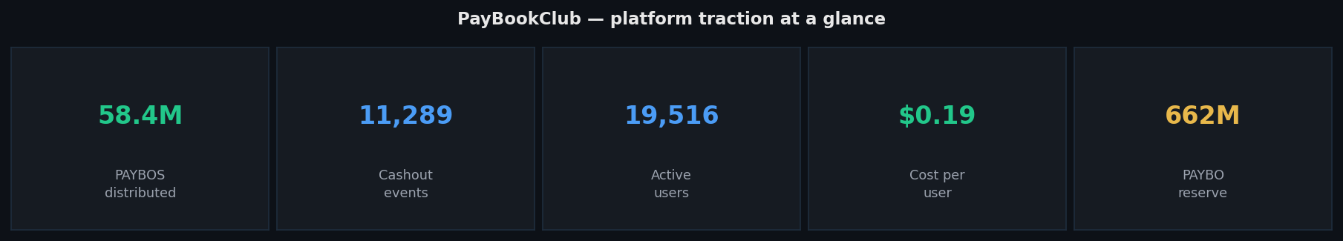

Cashout growth — 32x in 6 months
Monthly cashout events grew from 6 in November 2025 to 192 in April 2026 — a 32x increase in just 6 months — reflecting genuine user trust and growing token utility as the PAYBO price improved.
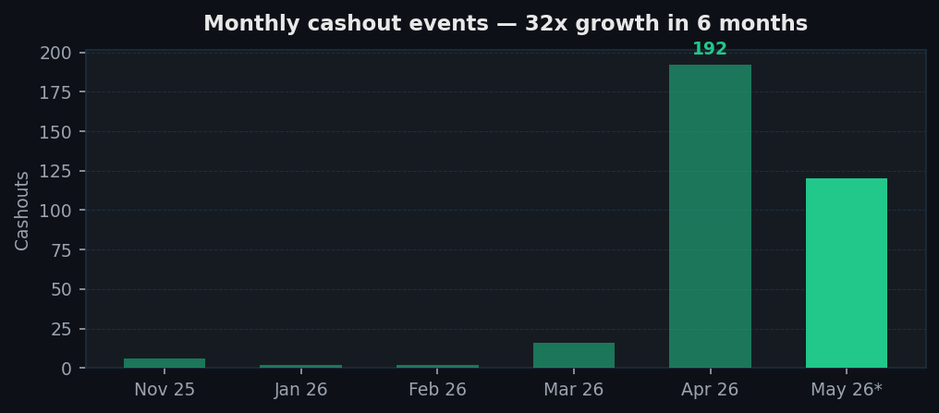

Revenue vs reward cost — path to profitability
Revenue is projected to cross reward costs around Q1 2027, driven by India expansion, ContentBox ad revenue share, and DEX trading fee income. Projections are conservative and do not include ANDAL token proceeds.
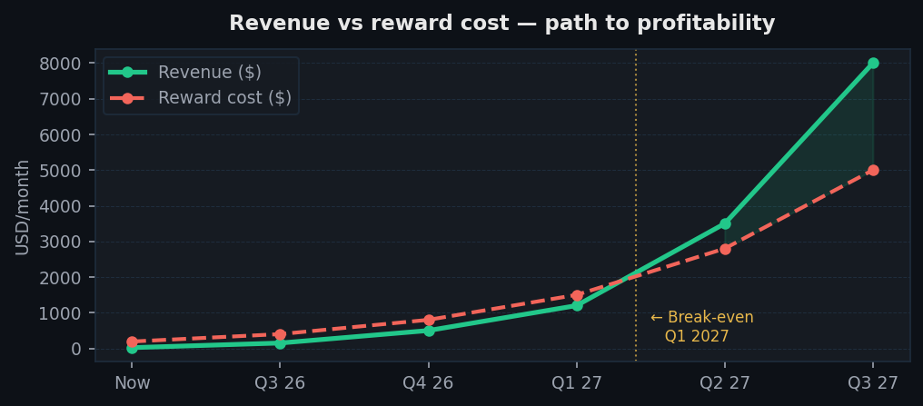

True cost of rewards — historical XLM context
Using a weighted historical average of ~$0.10/XLM over 6 years, the total dollar cost of all 58.4M PAYBOS distributed is ~$3,700 USD — or $0.19 per user. The current-rate XLM figure on the dashboard overstates historical cost.
